Pre-Production Planning Document (PODCAST)

GENERAL INFO
- Your Name: Avishai Edelman
- PROJECT: Podcast

CREATIVE BRIEF
- What must it be?
Talking about the New York Rangers and the NHL

- Who is it for?
It is for hockey fans and New York Rangers fans, in particular

- How long must it be?
5 to 10 minutes

- What is your objective with the piece?
My objective is to share my thoughts on what the Rangers current and future possible success might look like and how they will achieve it.

- When is it due?
Pre-production planning due March 4th
Recording the podcast due March 11th

- What is the overall idea?
Share my point of view as to why I believe the Rangers are going to make the playoffs through discussing the Four Nations Faceoff, the tradeline and the teams that surround the Rangers who are fighting for a spot in the playoffs.
- What is the storyline summary?
- Opening: Introducing myself and the podcast
- Four Nations Faceoff/Former and current Rangers representatives
- NHL Trade Deadline: Who got traded? Who is on the trading block?
- Where do the Rangers sit in the standings? Will they make the playoffs?
  - Blue Jackets
  - Red Wings
  - Ottawa Senators
  - Boston Bruins
  - Montreal Canadiens

Closing: Thank you for listening more information on my website or contact me on my Instagram @AvishaiEdelman_

- Elevator pitch:
The New York Rangers will be a playoff team.
They have a lot of momentum heading into the end of the season.
They are playing well against top teams.
They are getting great goaltending.
They are scoring more.
Their top players are playing better.
The new players are fitting in well.
And the other teams that they are competing with are starting to falter.
The New York Rangers will be a playoff team!
- Tagline:
- New York Rangers Rise to the Occasion!
- The tallest mountains (Stanley Cup) are the most rewarding.

- Look and feel description:

MIND MAP
[Insert your Mind Map image here]
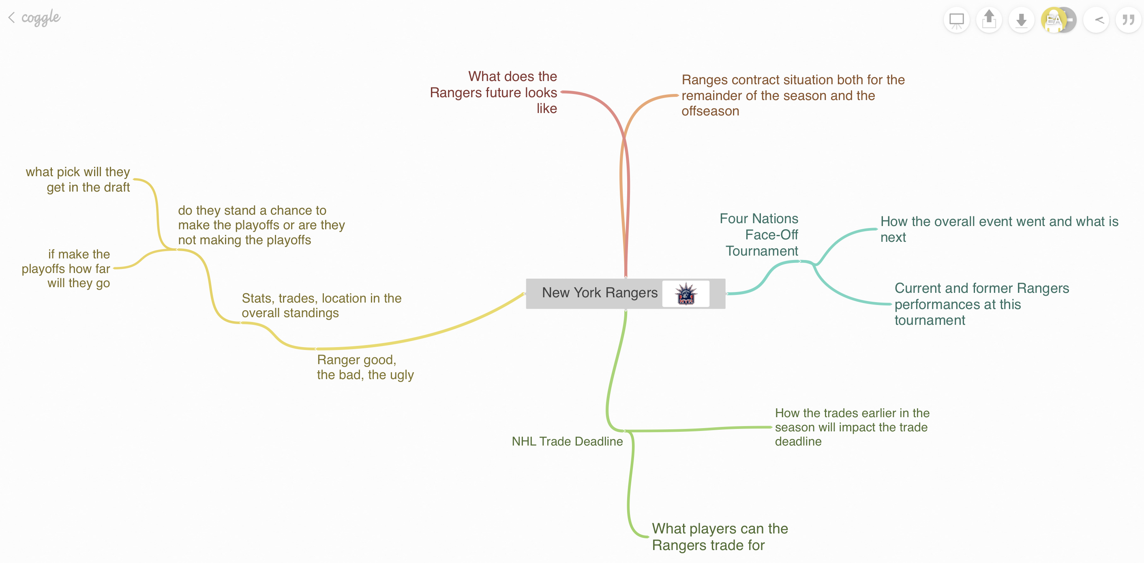

QUESTIONS / NOTES

HOOK:
- What will grab the attention of the audience within the first few seconds?
- Hook ideas:
The Rangers goal song and my passionate spirit for the Rangers and the NHL

MESSAGE/STORY:
- What message are you trying to deliver to the audience?
- Clearly describe the following parts of your story:
  - Beginning: Four Nations Faceoff/ Rangers former and current representatives
  - Middle: NHL Trade Deadline Who is on the trade block
  - End: Where in the standings do the Rangers sit are they making the playoffs or not

NARRATION/HOST:
- Who will lead us through the piece? Avishai Edelman
- Narration ideas:

Opening: Introducing myself and the podcast
- Opening: Introducing myself and the podcast
- Four Nations Faceoff/Former and current Rangers representatives
- NHL Trade Deadline: Who got traded? Who is on the trading block?
- Where do the Rangers sit in the standings? Will they make the playoffs?

Closing: Thank you for listening more information on my website or contact me on my Instagram @AvishaiEdelman_

MUSIC:
- What is overall “mood” and “feel” of the piece?
- Music track ideas:

- New York Rangers goal song (Slapshot)
- New York, New York or New York Rangers win theme song

AMBIENT AUDIO:
- What is the “location” of the piece? If we close our eyes, where should we imagine that we are?
- Ambient audio ideas:
In a college dorm room, dreaming about the Rangers making the playoffs.
Hockey Sounds | Download FREE Hockey sound effects | Zapsplat

SOUND EFFECTS:
- What sound effects (SFX) would help tell this story? Why?
- SFX ideas:
Rangers goal chant because it is one of the stand outs for Rangers hockey and I’ll use it after a “good” idea

(OPTIONAL) INTERVIEWS:
- Who will you interview?
- Why is this person important to the piece?
- What questions will you ask?
- What follow-up questions might be important?

SCRIPT

Name: Avishai Edelman
Title: Blue Shirts No Shirts

VIDEO | AUDIO
(NO VISUALS FOR AUDIO PROJECT) | Sample:  - Start off with Ambient Audio: Hockey Sounds | Download FREE Hockey sound effects | Zapsplat or New York Rangers goal song (Slapshot)  - Introducing myself and the podcast (said in a high energy, excited voice).  Hi, this is Avishai Edelman. Welcome to my first podcast about the NY Rangers. I am so excited to be here with you today to talk about OUR NY RANGERS and the exciting opportunity that they have this year to make the Stanley Cup Playoffs. It was a tough beginning of the year, but the Blue Shirts are turning it around just in time. It all started with...  - Four Nations Faceoff/Rangers former and current representatives  - Urho Vaakahanin (Finland)-stats  - Kappo Kakko (Finland)-stats  - Mika Zibanejad (Sweden)-stats  - Adam Fox (USA)-stats  - Chris Kreider (USA)-stats  - Vincent Trocheck (USA)- stats  - J.T. Miller (USA)- stats  - NHL Trade Deadline: Who got traded? / Who is on the trade block?  - Kappo Kakko (SEA)  - Jacob Trouba (ANA)  - Filip Chytil (VAN)  - Victor Mancini (VAN)  - Ryan Lingren (COL)  - Jimmy Vessy (COL)  - Who did they get?  - William Borgen  - Urho Vaakaninen  - J.T. Miller  - Erik Brannstrom  - Calvin de Haan  - Juuso Parssinen  Rangers player on trade block:  - Reilly Smith  - K’Andre Miller  - Chris Kreider  Players that the Rangers could get at the trade deadline:  SFX: New York Rangers Goal Horn Song or Rangers goal chant  - Where in the standings do the Rangers sit are they making the playoffs or not  New York New York Theme Song or New York Rangers win theme song

CREATE A PDF
When you are done creating this document, you should create a universal PDF document that can be easily posted to your blog or emailed (it’s not safe to assume everyone has Microsoft Word, and the files can be very large).

To do this on a Mac, click File>Print and then click the option for PDF in the lower left, followed by “Save to PDF”. Contact me if you need help on a PC.

These activities support Learning Objectives #1-5
Complete the following.
- Assignments:
- RESEARCH TO INFORM: Do some searching and find 3-5 specific audio projects (podcasts or commercials) that you think are well produced and effective at engaging the audience.
- Embed the audio or post a link to each on your blog/website with a few sentences that explain why you chose it. Try to analyze the format they used, and the flow of what we hear.
- *Note: Some artists or copyright holders may not want their work reproduced on anyone else's site (i.e. your blog), so if needed, feel free to just post a link to the page with enough of a description so that we can find it.
- CREATE: OVERVIEW: Between this week and the next, you will create your own audio Podcast on a PSA or human-interest topic of your choosing.
- Plan on a 2:00 minute to 10:00 minute finished piece.
- *NOTE: Contact me if you want to create a piece longer than 10 mins.
- It should be original, compelling and/or persuasive, innovative, engaging, creative, and interesting.
- Must include voice (narration and/or interviews), music, ambient audio, and sound effects.
- (OPTIONAL) to interview/record someone else.
- In this module: Create a Mind Map for your own podcast. Link above for free online Mind Map tool.
- You may create multiple Mind Maps to explore different ideas.
- Save a JPG of your finished Mind Map to add to your planning document.
- In this module: Completely fill out the "Pre-Production Planning Document (PODCAST)" for your own podcast. Link above for the template file.
- *Note: Fill out all 5 pages! The last page is a SCRIPT TEMPLATE. You can use that to script out as much as you want, but the MINIMUM is a detailed outline of the topics and flow with estimated time for each specific part.
- Be specific with ideas for music, ambient audio, and sound effects.
- Post the completed template to your blog/website (PDF format), along with a short writeup with your thoughts on the process. Why did you choose this topic? What challenges might come up?
- DUE DATES: The assignments above are due: 3/4/25 by noon.

NOTE*: All podcasts will be able to be successfully completed using a smartphone, computer or tablet and edited on free software Audacity.com or Adobe here in the labs. It is a good idea to download it ahead of next week’s module. You may use any audio recording equipment and editing software you choose but wanted you to be aware it is not necessary to purchase anything.

